Grieg Seafood ASA

Introduction of company:

Grieg Seafood ASA (GSF) is an international fish farming company, specialising in Atlantic salmon. It was founded in 1992 and listed on the Oslo Stock Exchange in 2007. The company’s fish farms are located in Norway, the UK and Canada. The fish is processed and packed close to the farms, before being sent to the customer, via sales partner Ocean Quality (60% owned by GSF). Main customers are exporters and large wholesalers.

GSF.R

Martin

Mon Jan 21 13:02:54 2019

options(scipen = 9999)  
  
getwd()

## [1] "C:/Users/Martin/Documents/Økad 6.sem/BED-2032"

#symbols <- c("GSF.OL", "OSEBX.OL")  
  
#xts  
#getSymbols(symbols, src = "yahoo")  
  
#xts <- merge(GSF.OL, OSEBX.OL, join = "fill")  
  
  
#gsf_adj <- GSF.OL$GSF.OL.Adjusted["2014/"]   
  
  
#### read from excel (requires files in working directory)  
  
gsf <- read_excel("C:/Users/Martin/Documents/Økad 6.sem/BED-2032/GSFkursdata.xlsx") %>%  
 rename(date = "GSF", GSF = "Siste") %>%  
 arrange(date)  
  
str(gsf)

## Classes 'tbl_df', 'tbl' and 'data.frame': 1254 obs. of 2 variables:  
## $ date: POSIXct, format: "2014-01-17" "2014-01-20" ...  
## $ GSF : num 23.8 24.2 25.4 25.9 25.3 24.8 25 25.4 25.2 25.2 ...

summary(gsf)

## date GSF   
## Min. :2014-01-17 00:00:00 Min. : 21.80   
## 1st Qu.:2015-04-21 06:00:00 1st Qu.: 28.00   
## Median :2016-07-20 12:00:00 Median : 53.25   
## Mean :2016-07-17 01:50:14 Mean : 54.83   
## 3rd Qu.:2017-10-12 18:00:00 3rd Qu.: 75.75   
## Max. :2019-01-16 00:00:00 Max. :129.50   
## NA's :1

gsf %>%  
 filter(is.na(GSF))

## # A tibble: 1 x 2  
## date GSF  
## <dttm> <dbl>  
## 1 2015-05-22 00:00:00 NA

#22. mai 2015 er NA, legger inn en pris på 28   
#for beregne returns og matche osebx for beta  
#if newer dataset is downloaded indexing [335] will replace the wrong value.  
gsf$GSF[335] <- 28.0   
summary(gsf)

## date GSF   
## Min. :2014-01-17 00:00:00 Min. : 21.80   
## 1st Qu.:2015-04-21 06:00:00 1st Qu.: 28.00   
## Median :2016-07-20 12:00:00 Median : 53.25   
## Mean :2016-07-17 01:50:14 Mean : 54.81   
## 3rd Qu.:2017-10-12 18:00:00 3rd Qu.: 75.75   
## Max. :2019-01-16 00:00:00 Max. :129.50

ggplot(gsf, aes(x=date, y=GSF)) +  
 geom_line()

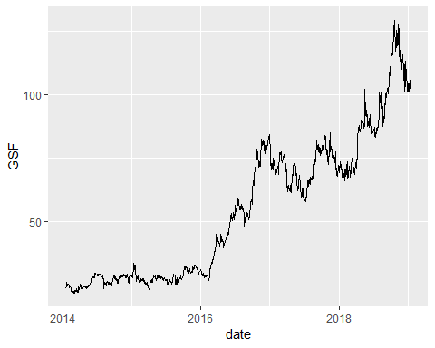

#returns_log <- gsf %>%  
# tq_mutate(mutate_fun = periodReturn, period = "daily", type = "log")  
  
gsf <- gsf %>%  
 tq_mutate(mutate_fun = periodReturn, period = "daily", type = "arithmetic")  
  
osebx <- read_excel("C:/Users/Martin/Documents/Økad 6.sem/BED-2032/OSEBXkursdata.xlsx") %>%  
 rename(date = "OSEBX", OSEBX = "Siste") %>%   
 arrange(date)  
  
summary(osebx)

## date OSEBX   
## Min. :2014-01-17 00:00:00 Min. :515.2   
## 1st Qu.:2015-04-21 06:00:00 1st Qu.:601.8   
## Median :2016-07-20 12:00:00 Median :635.8   
## Mean :2016-07-17 01:50:14 Mean :683.2   
## 3rd Qu.:2017-10-12 18:00:00 3rd Qu.:787.3   
## Max. :2019-01-16 00:00:00 Max. :946.4

gsf <- osebx %>%   
 tq_transmute(mutate_fun = periodReturn, period = "daily", type = "arithmetic") %>%  
 full_join(gsf, by = "date") %>%  
 rename(market.returns = "daily.returns.x", gsf.returns = "daily.returns.y")  
  
gsf <- gsf[c(1,3,4,2)]  
  
  
ggplot(gsf, aes(x=date, y=gsf.returns)) +  
 ggtitle("Arithmetic daily returns") + geom_line()

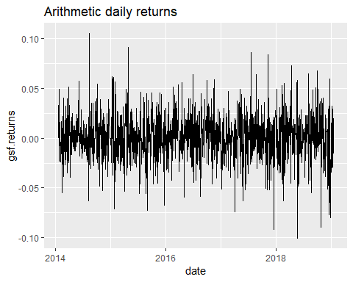

#choose 1 of the histograms, but which one?  
hist(gsf$gsf.returns, breaks = 30)

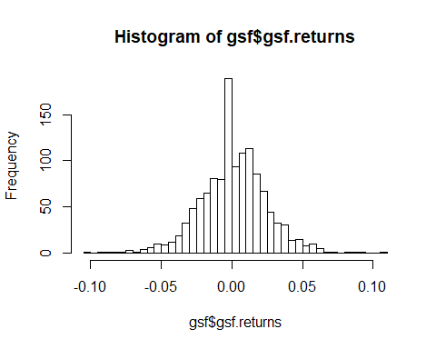

b <- ggplot(gsf, aes(x=gsf.returns))  
b + geom_histogram(bins = 30)

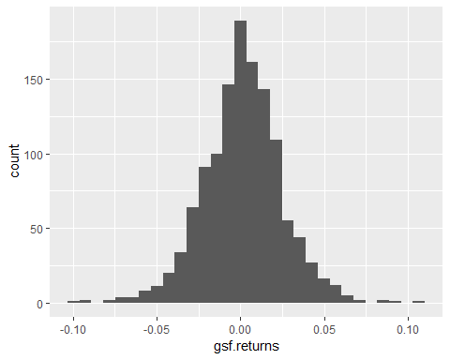

b + geom_density()

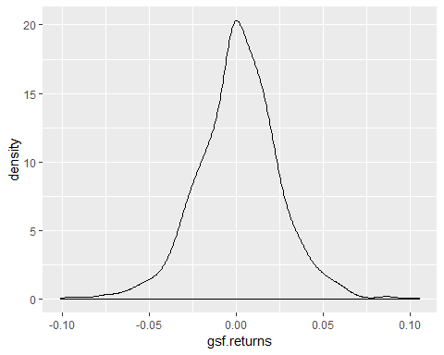

#Histogram with proportions calculated  
r.hist <- hist(gsf$gsf.returns, breaks = 20, plot=FALSE)  
r.hist$counts <- r.hist$counts/sum(r.hist$counts)  
plot(r.hist, xlab = "Daily arithmetic returns", ylab = "Proportion")

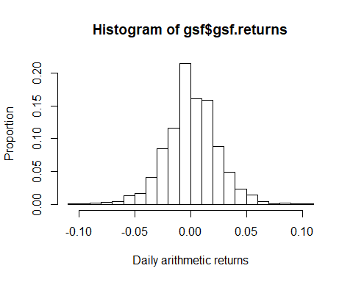

favstats(gsf$gsf.returns)

## min Q1 median Q3 max mean  
## -0.1006843 -0.0125 0.0006702248 0.01541428 0.1054852 0.001471738  
## sd n missing  
## 0.02365259 1254 0

gsf_sum <- gsf %>%   
 summarise(ann_mean = mean(gsf.returns)*252,  
 ann_sd = sd(gsf.returns) * sqrt(252),  
 skewness = skewness(gsf.returns),  
 kurtosis = kurtosis(gsf.returns),  
 sharpe = (ann_mean - 0.02)/ann_sd, #risk-free in CAPM set to 2%  
 beta = cov(gsf.returns, market.returns)/var(market.returns))   
  
gsf_sum$ann_mean <- percent(gsf_sum$ann_mean)  
gsf_sum$ann_sd <- percent(gsf_sum$ann_sd)  
gsf_sum

## # A tibble: 1 x 6  
## ann_mean ann_sd skewness kurtosis sharpe beta  
## <S3: formattable> <S3: formattable> <dbl> <dbl> <dbl> <dbl>  
## 1 37.09% 37.55% -0.102 1.35 0.934 0.753

#alternative: built-in function for CAPM beta.  
tq_performance(gsf, gsf.returns, market.returns, performance_fun = CAPM.beta)

## # A tibble: 1 x 1  
## CAPM.beta.1  
## <dbl>  
## 1 0.753

#todo: discuss summary statistics  
# analyse market position  
# calculate WACC  
# WACC = EKandel * cost of equity + gjeldsandel * cost of debt *(1-tax)  
#Cost of quity = utbytteandel?  
#cost of debt = vanlig gjeldsrente?

**Assignment part 4:**

Comment on liquidity of stock: Very liquid, part of the OBX index (25 most liquid on Oslo Stock Exchange). Extreme cases of volume: Marine Harvest sold all their shares (approximately 25% of existing shares in GSF).

Comment on the level of unsystematic risk:

Risk factors for GSF and seafood-sector:

* Harmful for the environment, problematic for attracting investors, possibly increased taxes from government.
* Lakselus and illness, problematic for product quality and environment.
* Salmon price

**Assignment part 5:**

Long term debt to equity ratio:

2017 2016 2015

Total debt *1000: 3 804 710 3 561 087 3 698 264

Total equity *1000: 3 347 905 3 206 951 2 237 511

Ratio 1,14 1,11 1,65

Long-term ratio = (2015+2017)/2: 1,395

Kvartalsstall fra 4. Kvartal 2018?

Compare ratio to competitors such as Salmar, Mowi and Lerøy osv.

Comment:

Comment on the capital structure and financial leverage:

Solid structure with a large proportion of equity, close to 50%. Very little financial distress as no signs of bankruptcy. Could increase leverage to increase benefits of tax shield.

Calculate or find average tax rate, EBIT and total interest expense:

Corporate tax rate in Norway:

2014 27%

2015 27%

2016 25%

2017 24%

2018 23%

Average tax rate: 25,2 %

Grieg Seafood EBIT:

2014: 219 366 000 NOK

2015: 80 951 000 NOK

2016: 1 560 836 000 NOK

2017: 798 480 000 NOK

Grieg Seafood interest expenses (finanskostnader):

2014: -107 521 000 NOK

2015: -131 357 000 NOK

2016: -155 213 000 NOK

2017: -56 789 000 NOK

Using long-term debt and interest expense, calculate the average cost of debt:

RD = *(1-tc)

Comment on your findings:

**Assignment part 6:**

Calculate firm’s market value and book value:

Market cap in NOK per 11.02.2019:

Number of shares: 111 662 000

Market price per share (111,40 NOK)

Market cap = 12 439 146 800 NOK

Book value (balance from 2017): 3 347 905 000 NOK

Market/Book = 3,715

Has the company issued debt or equity in the last 5 years?8

From cash flow 2017: Issued long-term debt for 300 million NOK

From cash flow 2015: Issued long-term debt for 650 million NOK

From cash flow 2014: Issued long-term debt for 895 million NOK

In the same period, no equity has been issued.

Carry out a Z-score analysis and comment on the results: